INVITATION TO TENDER
SAVE THE CHILDREN INTERNATIONAL

SUDAN
15th of September 2026
SCI/SDN/2026/ITT/ 748124

TENDER FOR PROVISION OF PR748124-Learning, Teaching Materials

PART 1 : INVITATION TO TENDER
  - Introduction to SCI
  - Project Overview and Requirements
  - Award Criteria
  - Instructions & Key Information

PART 2 : CORE REQUIREMENTS AND SPECIFICATION
Detailed description of SCI’s specific requirements (e.g. volumes, delivery dates / locations, product specifications etc).

PART 3 : BIDDER RESPONSE DOCUMENT
Template to be used to submit response to this Invitation to Tender.

PART 1 – INVITATION TO TENDER

INTRODUCTION TO SAVE THE CHILDREN

SCI is the world’s leading independent organisation for children. We save children’s lives; we fight for their rights; we help them fulfil their potential. We work together, with our partners, to inspire breakthroughs in the way the world treats children and to achieve immediate and lasting change in their lives.

Our Vision – a world in which every child attains the right to survival, protection, development and participation.

Our Mission – to inspire breakthroughs in the way the world treats children and to achieve immediate and lasting change in their lives.

We do this through a range of initiatives and programmes, to:

- Provide lifesaving supplies & emotional support for children caught up in disasters (e.g. floods, famine & wars).
- Campaign for long term change to improve children’s lives.
- Improve children’s access to the food and healthcare they need to survive.
- Secure a good quality education for the children who need it most.
- Protect the world’s most vulnerable children, including those separated from their families because of war, natural disasters, extreme poverty or exploitation.
- Work with families to help them out of the poverty cycle so they can feed and support their children.

For more information on the work we undertake and recent achievements, visit our website.

PROJECT OVERVIEW

Item | Description
Description of Goods / Services | Learning, Teaching Materials
Outcome of Tender | Fixed Price Framework Agreement – the successful supplier(s) will be awarded a ‘Framework Agreement’. Within the Framework Agreement, the terms of supply (e.g. indemnities, liabilities, warranties etc.) shall be agreed, as will the conditions of supply (e.g. specifications, lead times etc.). The Framework Agreement does not commit SCI to any purchases or specific volumes. Any future purchases which will be completed under separate Purchase Orders which will be governed and linked to the original Framework Agreement.
Duration of Award | 1 Years

Further detail on the specific requirements of the project (e.g. volumes, dates, specifications etc.) can be found in Part 2 (Core Requirements & Specifications) of this Tender Pack.

AWARD CRITERA

SCI is committed to running a fair and transparent tender process and ensuring that all bidders are treated and assessed equally during this tender process. Bidder responses will be evaluated against four weighted categories of criteria: Essential Criteria, Sustainability Criteria, Capability Criteria, and Commercial Criteria.

ESSENTIAL CRITERIA
Criteria which bidders must meet in order to progress to the next round of evaluation. If a bidder does not meet any of the Essential Criteria, they will be excluded from the tender process immediately. These criteria are scored as ‘Pass’ / ‘Fail’.

3.2 SUSTAINABILITY CRITERIA (10%)
Criteria used to evaluate the impact a supplier has on the environment, local economy and community. Bids will be evaluated against the same pre-agreed Criteria.

3.3 CAPABILITY CRITERIA (50%)
Criteria used to evaluate the bidders ability, skill and experience in relation to the requirements. Bids will be evaluated against the same pre-agreed Criteria.

3.4 COMMERIAL CRITERIA (40%)
Criteria used to evaluate the commercial competitiveness of a bid. Bids will be evaluated against the same pre-agreed Criteria.

VETTING

Successful bidders must be successfully vetted. This involves checking bidders and key personnel against Global Watch Lists, Enhanced Due Diligence Lists and Politically Exposed Persons Lists.

The vetting of bidders will be completed after the award decision and prior to any contract being signed, or orders placed. If any information provided by the Bidder throughout the tender process is proved to be incorrect during the vetting process (or at any other point), SCI may withdraw their award decision.

BIDDER INSTRUCTIONS

6.1 TIMESCALES

Activity | Date
Issue Invitation to Tender | 15/09/26
Deadline for questions from Bidders | 19/09/26
Deadline for Bid Submission | 23/09/26
Bid Clarifications | 25/09/26
Award Contract/Framework Agreement | 03/10/26

The above dates are for indicative purposes only and are subject to change.

6.2 SUBMISSION FORMAT & BIDDER RESPONSE DOCUMENT
Bidders wishing to submit a bid must use the Bidder Response Document template in Part 3 of this Tender Pack. Any bids received using different formats, or incomplete bids, will not be accepted.

This document allows bidders to submit all the required information and be evaluated fairly and equally against the Essential, Capability and Commercial Criteria. Bidders may also be required to submit supporting documentation. Further instructions can be found within the document in Part 3 of this pack.

Bids can be submitted by:

Paper Submission (Hard Copy)

- Bids must be submitted as a hard copy (paper submission) directly to the SCI River Nile Office, located on Alshargi Street, Alshabia, Block 5, Atbara.
- Location Coordinates: 15.675957520698578, 32.49292277964366.

Submission Address: SCI River Nile Office
Alshargi Street, Alshabia, Block 5, Atbara., Sudan
GPS Coordinates: 15.675957520698578, 32.49292277964366

6.4 CLOSING DATE FOR BID SUBMISSION

Your bid must be received no later than 23rd of September 2026 (4:00 PM).
Bids must remain valid and open for consideration for a period of no less than 60 days.

6.5 KEY CONTACTS

All questions relating to the tender should be sent via email to: (But not Bid Submissions)

Name | Mustafa Mohamed
Email | Mustafa.Elfaki@savethechildren.org
Position | Supply Chain Coordinator
Contact No. | +249912131152

Name | Omnia Kamal
Email | Omnia.Kamal@savethechildren.org
Position | Education Officer
Contact No. | +249111765461

Please be advised that local working hours are 8:00 AM to 4:00 PM (Sunday to Thursday). Please allow up to 2 Days for a response.

Where the enquiry may have an impact on other bidders within the process, Save the Children will notify all other Bidders to maintain a fair and transparent process.

PART 2 – CORE REQUIREMENTS & SPECIFICATIONS

- SPECIFIC REQUIREMENTS: Under this tender, Save the Children is currently looking to engage the service of Vendors to supply Learning and teaching material in River Nile and per the following requirements:

- Goods Required under this tender: Learning and teaching material as listed in Scheduled in ITT.

- Delivery Location & Incoterms: Atbara, River Nile State, Sudan SCI Warehouse

- Financial/Commercial Offer Requirements:

- Bidders are to submit their financial offer in UNIT PRICE form for the Goods listed in Section 4 of the ITT.

- Bidders are to submit their Financial/Commercial Offer in USD, and the submitted offers are expected to be under at least a 12-Month fixed pricing term.

- Bidders are to submit their Financial/Commercials, including all customs clearance costs, if applicable.

. Sample Submission Requirements
Bidders are required to submit a sample after clarifications.

PART 3 – BIDDER RESPONSE DOCUMENT

- INTRODUCTION

This document MUST BE USED by Bidders wishing to submit a bid. It is linked into 5 sections detailed below:

- Section 1 – Key Information
- Section 2 – Essential Criteria
- Section 3 – Capability & Sustainability Questions
- Section 4 – Commercial Questions
- Section 5 – Bidder Submission Checklist

The Bidder is required to sign a copy of the Check list in Section 4 as part of their submission.

- INSTRUCTIONS

Within each section there are instructions providing guidance to the bidder on what information is required. This guidance details the MINIMUM requirements expected by SCI. If a Bidder wishes to add further information, this is acceptable, but the additional information should be limited to only items that are relevant to the tender.

- For the avoidance of doubt, bidders are required to complete all items within the Bidder Response Document unless clear instruction is provided otherwise.
- If a Bidder does not complete the entire Bidder Response document, their submission may be declared void.
- If a Bidder is unable to complete any element of the Bidder Response Document, they should contact Save the Children through the using the contact details provided for guidance.

By submitting a response, the bidder confirms that all information provided can be relied upon for validity and accuracy.

SECTION 1 – KEY INFORMATION
Instructions – Bidders are required to complete all sections of the below table.
KEY INFORMATION
Organisation Name
Please provide details of the primary products/services supplied by your organisation
Please explain your experience of providing the goods or services requested in this tender document.
Website address
Address | Main Address | Registered Address  (if different) | Address for Payments  (if different)
Company Registration Number |  | Tax Number
Year of Registration |  | Country of Registration
Type of Business  (e.g. Manufacturer, Distributor, Contractor) |  | Primary Country of Operation
Total Annual Revenue  (please state the currency) | 2025 | 2024 | 2023
Annual Revenue
(from goods and services requested in this tender)
Have you supplied goods or services to SCI previously? If so, please provide a brief summary.
KEY CONTACT DETAILS
 | Primary Contact | Secondary Contact | Emergency Contact
Name
Job Title
Phone / Mobile
Email
Address
OTHER KEY INFORMATION
Provide details of what insurance cover you have and what the maximum value is
KEY ROLES & PERSONNEL
Which employees will be responsible for providing goods and services to SCI? Please list names, and job titles and contact details (e.g. account managers). | Job Title | Role | E-mail Address

SECTION 2 - ESSENTIAL CRITERIA
INSTRUCTIONS – Bidders are required to complete all sections of the below table.
Item | Question | Bidder Response
1 | Bidder accepts Save the Children’s ‘Terms and Conditions of Purchase’ and that any business awarded to the bidder will be completed under the Terms and Conditions included in Section 5 of this pack. | Yes / No | Comments / Attachments
2 | The Bidder and its staff (and any sub-contractors used) agree to comply with SCI and the IAPG’s policies listed in Section 5 of this pack throughout this tender process, and during any future works should the bidder be awarded a contract.  - Terms & Conditions of Bidding  - Child Safeguarding Policy  - Anti-Bribery & Corruption Policy  - Human Trafficking & Modern Slavery Policy  - Protection from Sexual Exploitation & Abuse  - Anti-Harassment, Intimidation & Bullying Policy  - IAPG Code of Conduct | Yes / No | Comments
3 | The bidder confirms they are not a prohibited party under applicable sanctions laws or anti-terrorism laws or provide goods under sanction by the United States of America or the European Union and accepts that SCI will undertake independent checks to validate this. | Yes / No | Comments
4 | The Bidder confirms it is not linked directly or indirectly to any terrorism related activity and does not sell any Dual-Purpose goods/services that may be used in a terror-related activity. | Yes / No | Comments
5 | The Bidder confirms it is fully qualified, licensed, and registered to trade with Save the Children (including compliance with all relevant local Country legislation).  This includes the Bidder submitting the following requirements (where applicable):  - Business registration certificate | Yes / No | Comments
5 |  | Requirement | Bidder Response / Attachments
5 |  | Business Registration Certificate
6 | Bidder is available and can deliver ALL the items listed in Section 4 of the ITT. Can submit for all items. | Yes / No | Comments

SECTION 3 – CAPABILITY & SUSTAINABILITY QUESTIONS
Instructions – Bidders are required to complete all sections of the below table.
Item | Question | Bidder Response
1 | REFERENCES  Bidder to share 3 Reference examples of their experience in providing services similar to those included within the scope of the RFQ and with UN Agencies, INGO, or Large MNC (if applicable). Examples must include:  - POs with INGOs or Companies and Large MNCs (if applicable).  AND/OR  - Contracts or Contacts with INGOs and Large MNCs  - Reference value will not be less than 30,000 USD | Please Attach Supporting/Relevant Documents
2 | The bidder accepts payment after completion of the service/GRN, without any advance payment. | Bidder Response
3 | Bidder can meet the  requirements set out in the RFQ  - Volume  - Lead times (14 Days)  - Specifications
4 | Bidders are responsible for ALL defects/losses before the transfer of ownership is complete | Bidder Response

SUSTAINABILITY CRITERIA

Item | Question | Bidder Response
1 | The Bidder’s workforce is 100% staffed from Sudanese nationals. | Bidder Response | Comment (s)
2 | The Bidder is registered / has its primary operations in close proximity to the delivery location to River  Nile State, Atbara, . | Bidder Response | Comment (s)

SECTION 4 – COMMERCIAL QUESTIONS

# | Question | Bidder Response
1 | Bidder is to provide a financial offer with fixed pricing terms for a minimum duration of 12 Months. | Yes / No  (If no, please SPECIFIY how long the fixed pricing period is)

 |  | Bidders is expected to fill out the table below
Line # | Description of Goods / Services |  |  | Photo | Unit | Currency | Quantity | Unit Price | Total Price | Lead Time
1 | Arabic notebook Indonesia 60 paper – كراس عربي اندونيسي |  |  |  | PCS | USD | 72,000
2 | Sharpener high quality metal براية جودة ممتازة حديد |  |  | 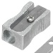 | PCS | USD | 16,000
3 | Erasers Roco مساحة روكو |  |  | 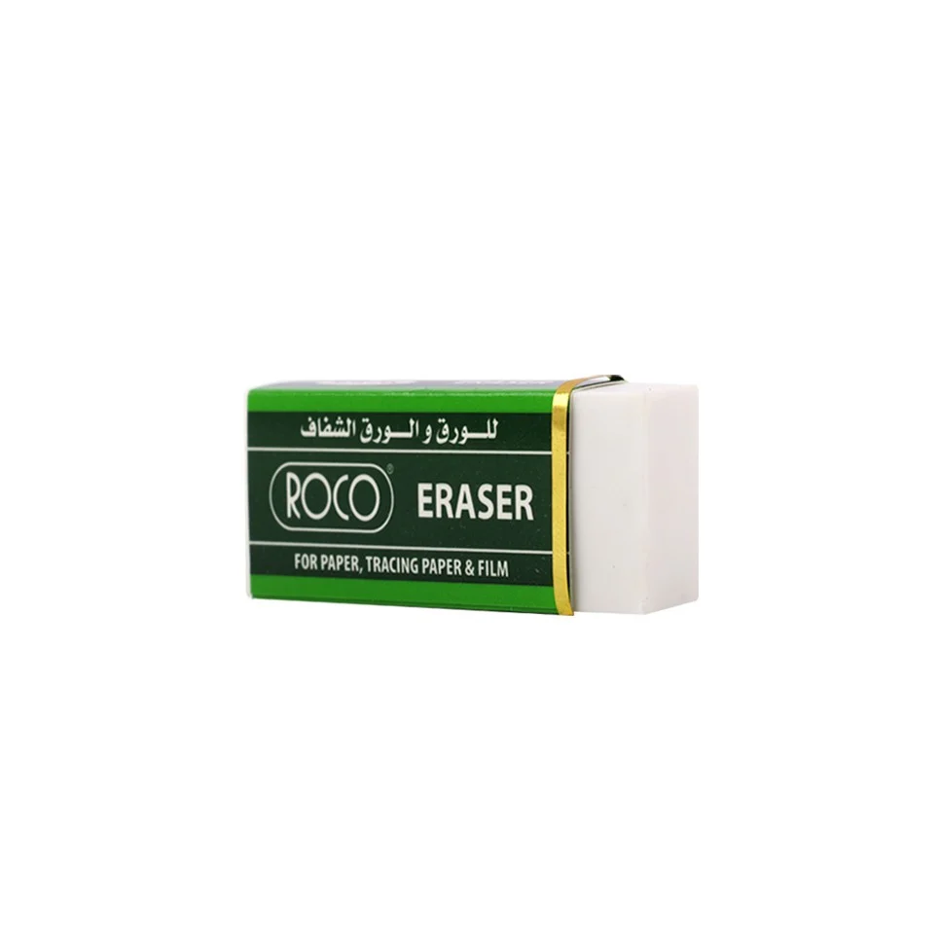 | PCS | USD | 16,000
4 | Pencil Roco  قلم رصاص روكو بالقطعة |  |  | 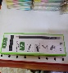 | PCS | USD | 48,000
5 | Blue Pen high quality (BOX50PCS) (pick) قلم بك اصلي |  |  | 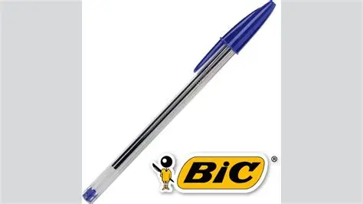 | BOX | USD | 188
6 | Ruler high quality 30cm مسطرة بلاستيك 30cm |  |  | 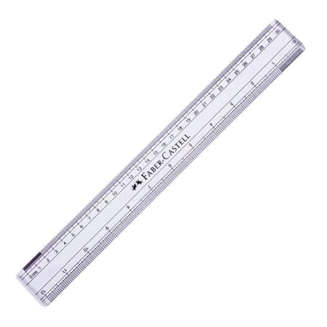 | PCS | USD | 5,000
7 | Geometric set for student ROCO علبة هندسة للطلاب ماركة روكو |  |  | 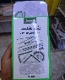 | PCS | USD | 3,000
8 |  |  |  | 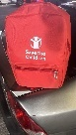 | PCS | USD | 4,000
  Red back bag medium size with logo in middle
  18 inch شنطة ظهرحمراء مقاس وسط
9 | Lesson preparation notebook 200 A5. Outer cover is red and bears the logo كراسات تحضير 200 ورقة بغلاف لون احمرA5 SCI |  |  |  | PCS | USD | 280
10 | White chalk طبشير ابيض تايلاندي(BOX 100 PCS) |  |  |  | BOX | USD | 210
11 | Coloured Thailand chalk طبشير ملون تايلاندي (BOX 100 PCS) |  |  |  | BOX | USD | 140
12 | Red Pen Pick قلم احمربك (50PCS for Box) |  |  | 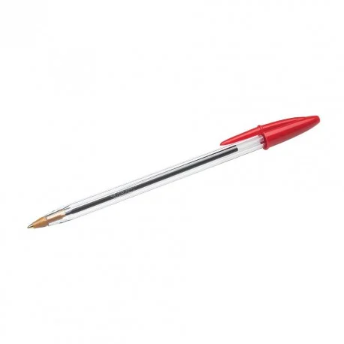 | BOX | USD | 56
13 | Colored Poster paper 100 paper in roll Manella ورق بوستر مانيلا |  |  |  | Roll | USD | 14
14 | Marker Pen white board قلم ماركر |  |  | 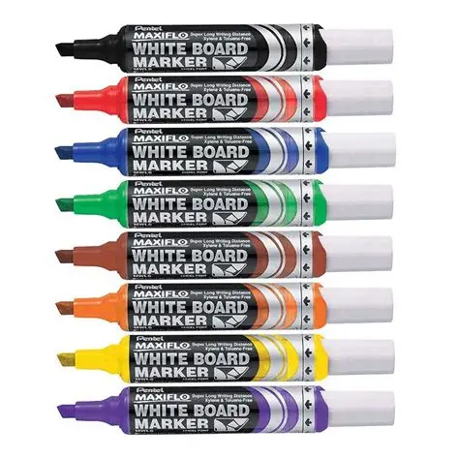 | BOX | USD | 28
15 | A4 Paper Omnia 80 gm ورق أمنية A4 (1 carton = 5 Pack) |  |  | 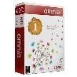 | Carton | USD | 28
16 | Clear Glue Roco (1 Pack = 4 PCS) غراء شفاف ماركة روكو |  |  | 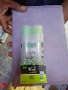 | Pack | USD | 14
17 | Geometric Set for teachers  SCI طقم معلم هندسي خشبي علية شعار |  |  |  | Kit | USD | 28
18 | File box black بوكس فايل اسود كبير |  |  | 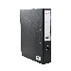 | PCS | USD | 70
19 | Registration book A3 outer cover is red and bears the logo SCI دفتر تسجيل بالون الاحمر مع شعار |  |  |  | PCS | USD | 70
20 | Stapler big size- kangaro-HP-45 دباسة كانقارو |  |  | 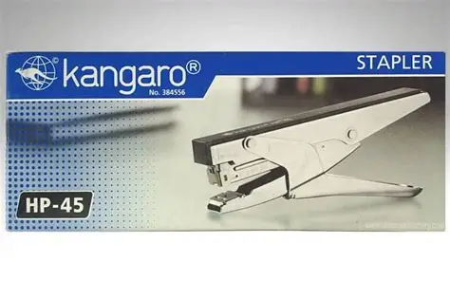 | PCS | USD | 42
21 | دبابيس دباسة كانقارو |  |  | 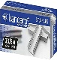 | Box | USD | 70
22 | Wooden ruler for teacher 1meter مسطرة معلم خشبي |  |  |  | PCS | USD | 84
23 | Exam envelope Aظروف امتحانات 3 |  |  |  | PCS | USD | 420
 |  |  | Total

SECTION 5 – BIDDER SUBMISSION CHECKLIST

We, the Bidder, hereby confirm we have completed all sections of the Bidder Response Document:
No | Section |  |  | Please Tick
1. | Section 2 – Essential Criteria
2. | Section 3 – Capability & Sustainability Questions
3. | Section 4 – Commercial Questions
We, the Bidder, confirm we have uploaded all of the required information and supporting evidence:
Section |  | Required Document / Evidence |  |  |  | Please Tick
Essential Criteria Evidence
 |  | Copy of business registration certificate
Capability Criteria Evidence |  | Completed Bidder Response Document
 |  | Supporting Financial Documents
Commercial Criteria Evidence |  | Completed Bidder Response Document
We, the Bidder, hereby confirm we compliance with the following policies and requirements:
Policy |  |  | Policy / Document |  | Signature
Terms & Conditions of Bidding
Terms & Conditions of Purchase
Child Safeguarding Policy
Anti-Bribery & Corruption Policy
Human Trafficking & Modern Slavery Policy
Protection from Sexual Exploitation & Abuse
Anti-Harassment, Intimidation & Bullying Policy
IAPG Code of Conduct

We confirm that Save the Children may in its consideration of our offer, and subsequently, rely on the statements made herein.
Signature: | …………………………………………………..
Name: | …………………………………………………..
Title: | …………………………………………………..
Company: | …………………………………………………..
Date: | …………………………………………………..

